(Airline Ticket Reservation System)

FINAL PROJECT REPORT
CSD 3204-Relational Database & SQL

Submitted to: M/sRachida.

Submitted by

Arundeep Singh c0740006
Xiao Wu c0727686
Manish c0734815
Parvinder Singh c0737389
Palwinder Kaur c0737690
Tejinder Pal Singh C0739088
Part-1

1).ERD diagram:

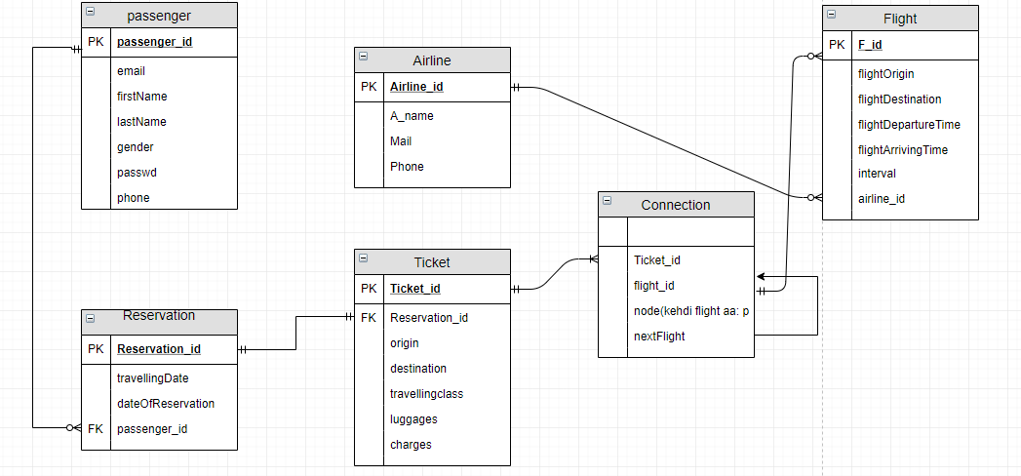

- Entities and attributes: There are 6 entities in in this database named as follow:
Note: All stared attributes are considered as Primary keys for their respective tables.

- Passenger: In order to store personal and login information of passenger (a person who is going to use this system). This entity has following 6 attributes:
      - Passenger_id*: It is unique id assigned to all users in order to carry out the functionality of this system.
      - Email: It is required by system in order to authorize the user. It is also used to contact the user in order to carry out feedback or general survey along with update him with new offers and deals. Moreover, it could be used to recover the account in case if user forgets his password.
      - FirstName: It stores the first name of passenger.
      - LastName: It stores the last name of passenger.
      - Gender: It states whether the passenger is male or female.
      - Passwd: It stores the password in order get logged into the account.
      - Phone: It stores the contact number of user.
Note: ‘user’ is a keyword in oracle, so it is referred as ‘passenger’.

b. Reservation: This entity is used to store reservations made by specific passengers. This entity has following 5 attributes:
- R_id*: It is unique id assigned to all reservations in order to carry out the functionality of this system and to keep track of reservations.
- travellingDate: It is used to the date of travelling. In other words, it is used to store the boarding date.
- DateOfReservation: It stores the date when reservation was made. And it is initialized to system date.
- Passenger-id: It is used to make connection of reservation with specific passenger.

c. Ticket: A carrier ticket is a document or electronic record, issued by an airline, that
affirms that an individual is qualified for a seat on a trip on a flying machine. This
entity has following 7 attributes.
(1) Ticket_id*: It is the unique id on the ticket assigned to the passenger travelling.
Using this id travelling details of the passenger can be fetched from the system.
(2) Reservation_id: This id is used to fetch the details of the reservations made by thepassengers.
(3) Origin: Origin is the place from where the passenger is departing.
(4) Destination: Destination is the place where the passenger is arriving.
(5) Travellingclass: It is the type of class such as Economy, Premium Economy,
Business, First class etc. in which the passenger is travelling.
(6) Luggages: It is the Baggage allowance for passengers and the limit of allowance
varies with the type of class and airline.
(7) Charges: It is the price or amount for the ticket issued to the passenger.

d. Connection: This entity requires the travelers to change from one plane or airline to
another at an intermediate point (called connecting point) on way to their destination.
(1) Ticket_id: Ticket id is the id on which the passenger travelling details are issued
and transitions are made from one place to another place.
(2) Flight_id: It is the id of the aircraft on which the passenger is travelling.
(3) Node: It is the airline on which the traveler will make a journey.
(4) Nextflight: It is the connecting flight on which the passenger will make a journey
to the destination.

e. Flight: It is the scheduled airplane trip that travelers make from one place to another
place. This entity has following 7 attributes.
(1) F_id*: It is the unique id of the airplane on which the traveler is making a
journey. Using this id, all the details of the aircraft can be fetched.
(2) Flightorigin: It is the place from where the passenger is boarding the plane.
(3) FlightDestination: It is the place where the passenger is landing.
(4) FlightDepartureTime: It is the scheduled time of the aircraft take off.
(5) FlightArrivingTime: It is the landing time of the flight arrival at the destination.
(6) Interval: It is the waiting time for a passenger between the arrival of the first flight
until the departure of next flight.
(7) Airline_id: It is the id of the aircraft carrier that is used to make flight bookings
for that carrier.

f. Airline: It is an organization providing a regular public service of air transportation
on one or more routes. This entity has following 4 attributes.
(1) Airline_id*: It is the unique id of the aircraft carrier that is used for multiple types
such as flight booking, flight rescheduling, flight Tracking etc.
(2) A_name: It is the name of the airplane carrier such as Air Canada, Lufthansa etc.
(3) Mail: It is the E-mail id of the Airline that is used to make a contact between
customer service and passengers.
(4) Phone: It is another type contact that is used by the airline for its customers to
directly speak to the airline associates.

2. Normalization:

Performing 1st normal form:
These tables are already in 1st normal form as they all have:
- Single(atomic) valued attributes/columns.
- Values stored in a column are of the same domain
- All the columns in a table have unique names.
Performing 2nd normal form:
These tables are already in 2nd normal form as:
- They are in First Normal form.
- And, did not have Partial Dependency.
Performing 2nd normal form:
These tables are already in 3rd normal form as:
- It is in the Second Normal form.
- And, it doesn't have Transitive Dependency.
So, let us move to next phase ie. Developing database.
3. Database develpment:

  - Creating tables.
DDL statementsfor creating tables andaddingconstraintsto them.

  - Passenger Table:

createtable passenger (
passenger_idnumberconstraintpassenger_pkprimarykey,
email varchar2(20) notnull,
firstname varchar2(10) notnull,
lastname varchar2(10) notnull,
gender varchar2(1) notnull,
passwd varchar2(16) notnull,
phone varchar2(12)
);

altertable passenger addconstraintpassenger_phone_uqunique (phone);

altertable passenger addconstraintpassenger_email_uqunique (email);

b. Reservation table:

createtable Reservation (
reservation_idnumber(10) constraintreservation_pkprimarykey,
travellingdatedatenotnull,
dateofbookingdatenotnull,
passenger_idnumber(10) foreign key passenger(passenger_id)
);

altertable reservation modify reservation_idnumber(10);

c. Ticket table

createtable ticket (
ticket_idnumber(10) constraintticket_pkprimarykey,
reservation_idnumber(10) notnull,
checkintimetimestampnotnull,
origin varchar2(15) notnull,
destination varchar2(15) notnull,
travellingClass varchar2(10) notnull,
luggagesnumbernotnull,
charger numbernotnull,
constraintfk_ticketreservationforeignkey(reservation_id) references reservation(reservation_id)
);

d. Connection Table

createtableConnection (
ticket_idnumbernotnull,
flight_idnumbernotnull,
node numbernotnull,
nextFlightnumber
);

altertableconnectionaddforeignkey (Ticket_id) references ticket(ticket_id);

altertableconnectionaddforeignkey (flight_id) references flight(flight_id);

e. Airline table

createtable Airline (
airline_idnumberconstraintairline_pkprimarykey,
airline_name varchar2(10) notnull,
mail varchar2(20) notnull,
phone varchar2(15)
);

altertable Airline addconstraintairline_name_uqunique (airline_name);
altertable Airline addconstraintairline_mail_uqunique (mail);
altertable Airline addconstraintairline_phone_uqunique (phone);

f. Flight table

createtable Flight (
flight_idnumberconstraintflight_pkprimarykey,
airline_idnumbernotnull constraint fk_flightairline foreign key references airline(airline_id),
flightorigin varchar2(10) notnull,
flightdestination varchar2(10) notnull,
flightdeparturetimetimestampnotnull,
flightarrivaltimetimestampnotnull,
intervaltimestampnotnull
);
Part-2

DML statementsfor manipulating data in tables

1)Data entry into tables that you have created.

- For passenger table

insertinto passengervalues(1000,'palwinder@email.com','Palwinder','Kaur','f','pal1000',32456);
insertinto passenger values(1001,'xiao@email.com','Xiao','Singh','f','xia1001',3232456);
insertinto passenger values(1002,'arun@email.com','Arun','Singh','m','aru1002',323246);
insert into passengervalues(1003,'parvinder@email.com','Parvinder','Singh','m','par1003',34223246);
insertinto passenger values(1004,'manish@email.com','Manish','kumar','m','man1003',3422324);
insertinto passenger values(1005,'manish@email.com','Manish','kumar','m','man1005',3422324);
insertinto passenger values(1006,'tejinder@email.com','Tejinder','Singh','m','tej1006',2422324);
insertinto passenger values(1005,'parsinni@email.com','parsinni','burhi','f','par1005',324567);
After inserting data into passenger table it seems like

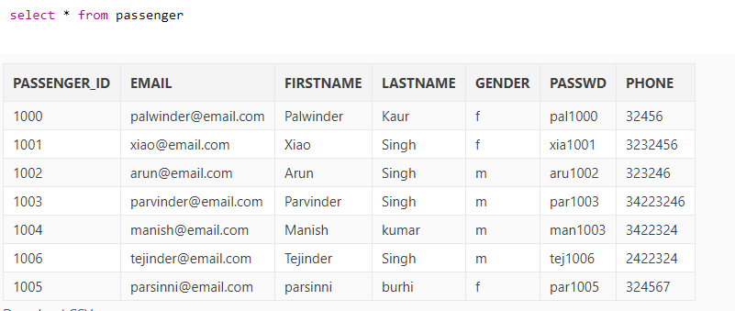

2) For reservation table
insertinto reservation values(10000,to_date('23-12-2018','dd-mm-yyyy'),sysdate,1003);
insertinto reservation values(10002,to_date('23-12-2018','dd-mm-yyyy'),sysdate,1001);
insertinto reservation values(10001,to_date('23-12-2018','dd-mm-yyyy'),sysdate,1004);
insertinto reservation values(10003,to_date('23-01-2019','dd-mm-yyyy'),sysdate,1000);
insertinto reservation values(10005,to_date('02-02-2019','dd-mm-yyyy'),sysdate,1006);
and so on….

After inserting data into reservation table it seems like

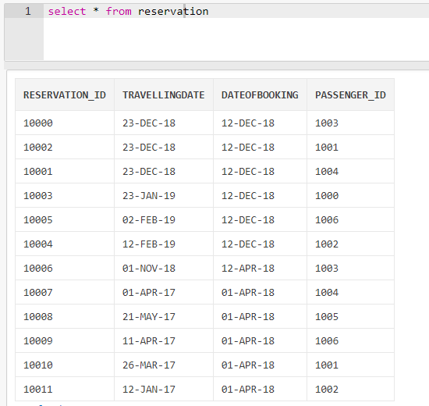

3) For ticket table

insertinto ticket values(100000,10001,'toronto','china','business',2,500);
insertinto ticket values(100001,10000,'toronto','china','business',2,500);
insertinto ticket values(100003,10003, ,'toronto','paris','economy',2,300);
insertinto ticket values(100004,10002,'delhi','new york','business',3,700);
insertinto ticket values(100002,10004,'zimbabwe','vancouver','business',3,670);
insertinto ticket values(100005,10005,'Amritsar','toronto','business',3,500);

After inserting data into ticket table it seems like

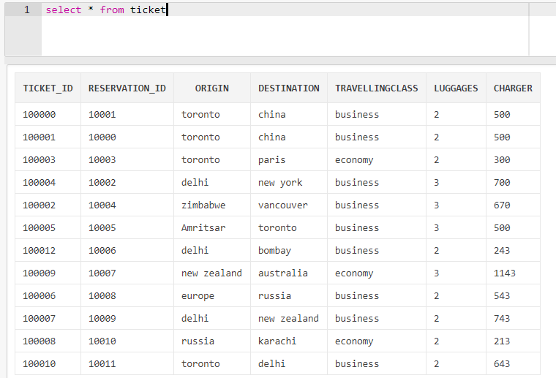

4) For airline table
insertinto airline values(77135,'Air us','airus@email.com',345366)
insertinto airline values(77134,'Air china','airchina@email.com',3453612)
insertinto airline values(77133,'Air India','airindia@email.com',34536324)
insertinto airline values(77132,'Air canada','aircanada@email.com',3453636)
insertinto airline values(77131,'Air france','airfrance@email.com',345436)
and so on..

after inserting data

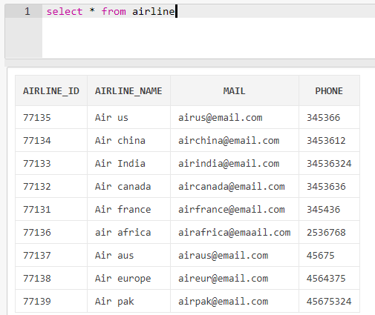

5) For flight table
insertinto flight values(2217,77135,'delhi','newyork','8:43am','1:40pm','13:3')
insertinto flight values(2216,77133,'delhi','toronto','7:00pm','9:00am','14')
insertinto flight values(2215,77134,'toronto','china','12:43am','11:45pm','10:58')
insertinto flight values(2214,77132,'zimbabwe','Vancouver','2:43am','1:40pm','13:3')
insertinto flight values(2213,77131,'toronto','paris','3:40pm','1:40am','10')
insertinto flight values(2218,'paris','delhi','4:40pm','3:00 am','10:20')
and so on….

After inserting values
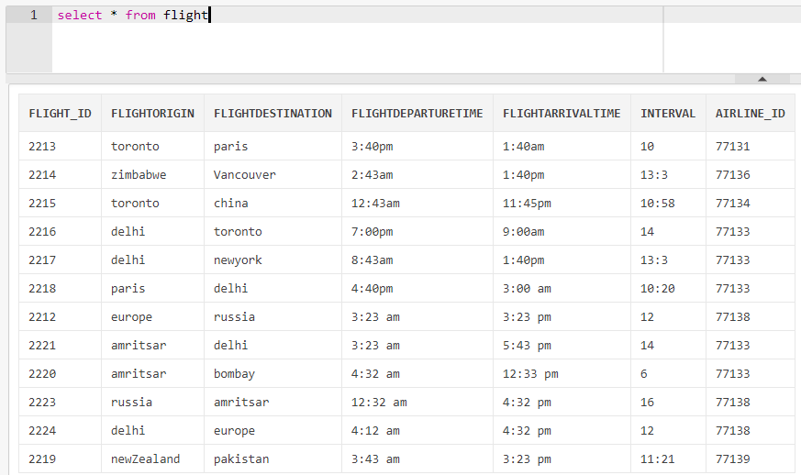

2. Travel history of a specific passenger

select origin, destination from ticket wherereservation_idin (selectreservation_id from reservation wherepassenger_id = 1003);
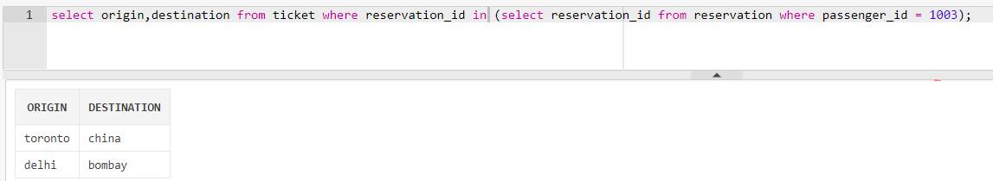

3.Total hours that a specific aircraft has served during a specific time interval

selectsum(interval) from flight whereflight_id = 2213;
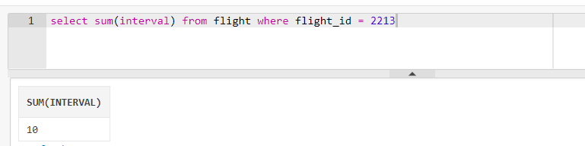

Total number of aircrafts belonging to a specific airline.

selectairline_id,count(*) from flight groupbyairline_id;

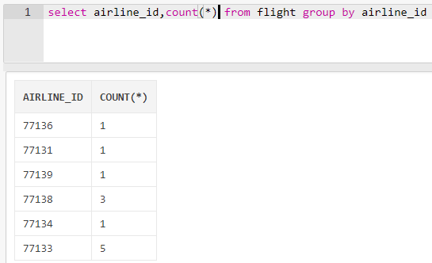

5. Total number of hours that a specific passenger has travelled during a specific time interval

selectsum(to_number(interval,'99.99')) asintervalfrom flight whereflight_idin (selectflight_idfromconnectionwhereticket_idin (selectticket_idfrom ticket wherereservation_idin (selectreservation_idfrom reservation wherepassenger_id=1006)));

6. Total number of hours that a specific airline has been running during a specific time interval

selectsum(to-number(interval)) asintervalfrom flight whereairline_id = 77139anddate='23-09-2017';

7.List of all passengers who flew to a specific city during a specific time interval.

selectfirstnamefrom passenger wherepassenger_idin (selectpassenger_idfrom reservation wherereservation_idin (selectreservation_idfrom ticket where destination = 'toronto'));

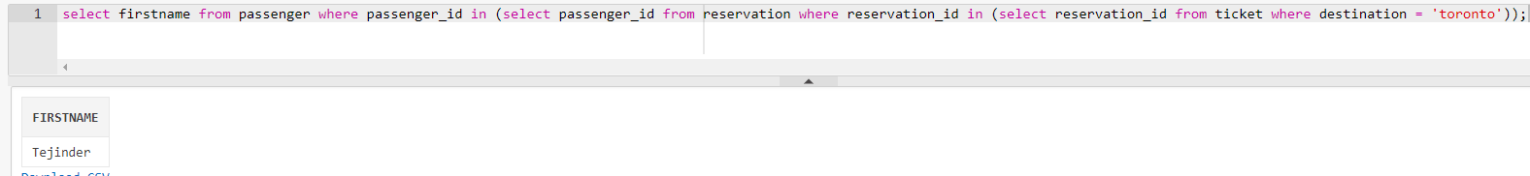

8. Most visited city during the last month.

select destination from ticket whererownum=1groupby destination orderbycount(*) desc;

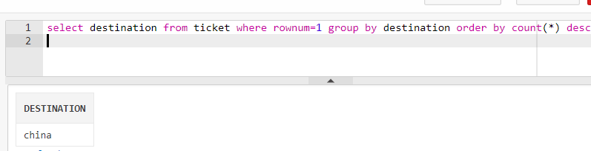

9. List of aircrafts that have not been in used from a specific source location.

selectflight_idfrom flight whereflightdestination<>'toronto';

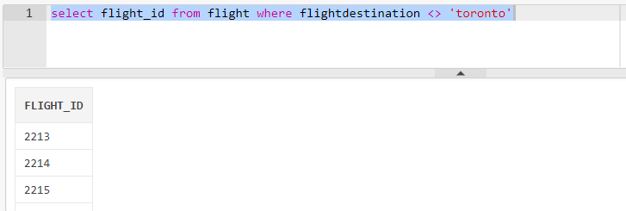

10.List of airlines that run flight from a specific source to a destination.

selectairline_idfrom flight whereflightdestination = 'toronto'andflightorigin = 'delhi';

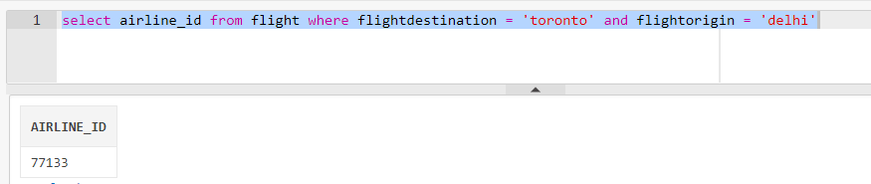

11. The list of all options that a passenger can have when travelling from a source to a destination. This includes a connecting flight, for instance, a passenger is travelling from Toronto to Dehli and there is no direct flight, therefore, you have to find the options for this passenger.

selectflight_id,(selectflight_idfrom flight whereflightdestination='china') asconnected_tofrom flight whereflightorigin='delhi'and (flightdestination='china'orflightdestinationin (selectflightoriginfrom flight whereflightdestination='china'));

12.What is the minimum number of hours that it will take for a passenger to travel from a source city to a destination city. Again, consider the connecting flights as mentioned in item number 9, e.g. travelling from Toronto to Dehli.

selectmin(interval) from flight whereflightdestination = 'toronto'andflightorigin = 'delhi';

